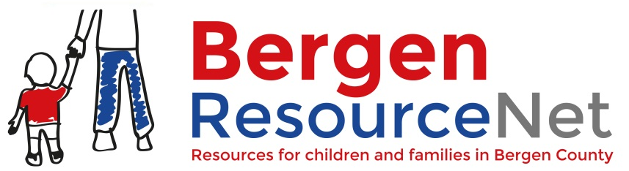

Does your agency/community/coalition/organization provide programs/services/groups/activities for Bergen County families?

Bergen ResourceNet is the “Google” for Bergen County Resources! This free online resource portal is mobile friendly and translatable to multiple languages.

This is a vital resource for anyone looking for, or offering local, community-based, health and wellbeing-related programs, services, support groups, events, webinars, professional development, and industry news for Bergen County families. Search for resources by keyword, zip code, category/need.
43,939
Unique users

35,661
Users via Google (78% of all referrals)

156,792
Total Page Views

45%
Users accessed BRN through mobile devices

216%
Quarterly Growth of Referrals via Social Media
(2019/Q1)
Don’t Miss Out on a Big Audience! Free Marketing Opportunity!
(2018)

Attention Providers/Community Based Organizations:
Designate an admin for your agency that will participate in a short web-based ResourceNet coaching session to learn how to promote your agency/organization events, services, programs, groups, etc. Learn how to optimize search results and easily find resources for clients. Email info@bergenresourcenet.org for available dates/times.
Help cross promote! Link to the Bergen ResourceNet from YOUR webpage today!

Bergen ResourceNet is maintained by Bergen’s Promise, a private, non-profit community-based organization providing home-based care management services for youth ages 5-21 living with behavioral, mental, substance, developmental and intellectual challenges.
www.BergenResourcenet.org

